I'm puzzled over these tracks. I thought when another user synced, if there wre changes there was a second sync that said Merge.

[2:14:48 PM] Ken Zook: 476 is a WeSay sync, 477 is a Flex sync, 478 just says Flex sync, but it was actually merging. Why?

[2:15:29 PM] Ken Zook: Then WeSay keeps syncing along and all of a sudden at 485 it decides to merge with the Flex 478?

[2:16:43 PM] Ken Zook: Adn at 479, When WeSay synced, why didn't it merge from 478?

[2:16:55 PM] Randy Regnier: 479 -> 484 arte all auto saves on WeSay with no attempt at S/R.

[2:17:25 PM] Randy Regnier: Then, 485 pulled the changed and merged them in.

[2:17:34 PM] Ken Zook: Ah, yes, so auto just does a sync to the local repo

[2:17:48 PM] Randy Regnier: WeSay does a lot of auto saves every few minutes, but without a pull and merge.

[2:17:57 PM] Randy Regnier: Right on the local repo.

[2:18:08 PM] Ken Zook: So 485 is when he actually did S/R?

[2:18:49 PM] Randy Regnier: Yes, but by that point, he had no new changes, so no commit called sync.

[2:22:46 PM] Ken Zook: So 494 flex synced and then merged. But if wesay was only auto at that point why did it merge from 493 instead of 485 when wesay did the last sync?

[2:22:47 PM] Randy Regnier: Then, it went right to the pull, got new stuff, and did a merge, and sent the me4rged stuff away.

[2:24:50 PM] Randy Regnier: The WeSay guy could have done a full S/R in there, right after an auto save, which would have sent those auto save off and ready for merge in 495.

[2:25:39 PM] Ken Zook: So if wesay does a S/R but nothing changed since the last auto save, it doesn't report anything?

[2:26:22 PM] Randy Regnier: Correct, since no new commit was done, since no new changes had been made, since the last auto save.

[2:27:42 PM] Randy Regnier: So, basically, WeSay jsut did a push on the last auto save.

[2:28:18 PM] Ken Zook: So now Flex does a merge at 495, syncs at 496,497 and when WeSay does an auto at 498 it is still working on it's local repo and doesn't see the flex syncs yet?

[2:28:29 PM] Randy Regnier: Then, the next thing was the Felx person doing an S/R with its commit, pull and merge (and following push).

[2:29:19 PM] Randy Regnier: Yeah, those auto saves on WeSay won't know about any new stuff from Flex, since that operation is commit locally only with no pull and merge.

[2:30:25 PM] Ken Zook: But then at 502 wesay does a sync and then flex does a sync at 503. Why didn't it merge there?

[2:33:05 PM] Randy Regnier: 497 wasa Flex S/R that sent stuff out. The WeSay had done nothing yet, but did an S/R and got the new stuff. Then WeSay started doing more auto saves. (up to 501).

[2:33:16 PM] Randy Regnier: Now, I'll look beyond 501.

[2:36:30 PM] Randy Regnier: Looks like at 502 that WeSay pushed the auto saves, and Flex got them, but had made no new changes. Then Flex did stuff and did an S/R in 503.

[2:37:09 PM] Randy Regnier: Then WeSay continued with the auto saves in 504 & 505.

[2:37:41 PM] Randy Regnier: There seems to be one more player that has no commits in that pic.

[2:38:17 PM] Ken Zook: Ok, that's starting to sync (sink) in now. I was missing a number of things in my reading the logs. It would be helpful to know when it actually picked up changes at times.

[2:38:20 PM] Randy Regnier: But, we can see the track (starts on the far left, and by 503 it has moved into the middle of the threesome.

[2:38:51 PM] Ken Zook: yes, that's another wesay user

[2:39:50 PM] Ken Zook: There are several anomolies I've been trying to track down for some time now. I've made some headway, but I haven't been able to reproduce the other things yet, so I'm trying to figure this out.

[2:39:54 PM | Edited 2:40:17 PM] Randy Regnier: We could 'tickle' the file with an almost do nothing change (say mess with a date stamp somewhere). That would force a commit, even if nothing was changed locally, but only new stuff was received.

[2:40:54 PM] Randy Regnier: That would record each bit in the commit history at the cost of having special code that did such messing.

[2:41:08 PM] Randy Regnier: 'benign messing' that is.

[2:41:13 PM] Ken Zook: So basically a sync may do only a read from the repo (not shown) or it may write to the repo which shows, and then it may merge and write again when needed.

[2:41:48 PM] Randy Regnier: Might not be worth it if one can imagine correclty how Hg works.

[2:41:54 PM] Ken Zook: right

[2:43:41 PM] Randy Regnier: But, yes, you are right, in that some pulls might not show up on Flex or WeSay, if the local machione had done nothing. Same for pushes if nothiong had been done since the last auto commit. Flex doens't do auto commits, so you won't see that kind of auto history for a Flex project.

[2:44:06 PM] Ken Zook: The current anomaly I'm trying to reproduce is strings that start with an embedded language. Flex keeps <text><span together because returns are significant following <text>, but wesay seems to default to <text>nl tab tab.. <span. When that happens in an example sentence, it can duplicate the examples.

[2:44:28 PM] Randy Regnier: Do nothing pulls and/or sends are possible in a Flex project S/R, but you won't see the auto save stuff in the mix.

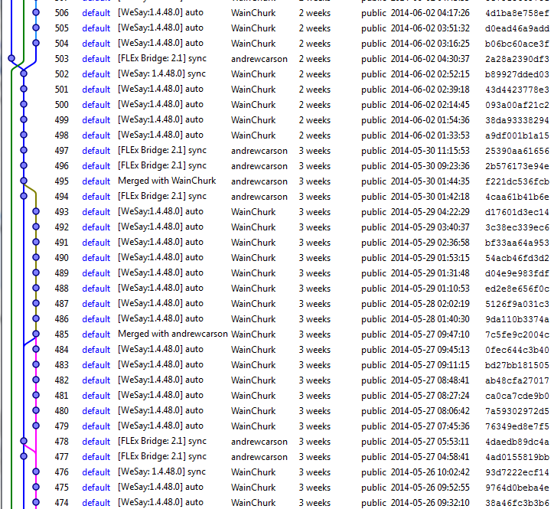

Strategy for Flex S/R Lexicon:

1. Export LIFT file to local repo directory.

2. See if anything changed on the remote repo, and if so, pull the changes and merge them with the exported LIFT file.

3, Commit the merged LIFT file to the LB repo.

4. Push the changes to the remote repo.

5. If anything changed for Flex, import the LIFT file into Flex.

6. If the LIFT import fails, add a file to the LB directory notifying FW of the problem and notify the user that the S/R failed.

WeSay will do an autosave about every 20 minutes. This just commits changes to the local repo with “auto” in the description and doesn’t do anything with the remote repo.

Strategy for WeSay S/R

1. If I have any changes not committed to the local repo, commit these changes to the local repo with “sync” in the description.
2. See if anything has changed on the remote repo.
   1. If there are no remote changes, see if I have any changes. If so, push them to the remote repo. If I don’t have changes, do nothing.
   2. If there are remote changes, see if I have any changes.
      1. If I don’t have changes, pull the remote data and use it without writing anything in the log.
      2. If I do have changes, pull the remote data, merge it with my changes, commit the merged data to the local repo with “merged” in the description, then push changes to the remote repo.

Flex S/R Lexicon

1. If a warning file is in the local LIFT repo directory from a previous failure, try importing the LIFT file from that directory. If it still fails, abort the S/R. If it succeeds, delete the warning file and go to the next step.
2. Save FLEx data to LIFT file in the local LIFT repo directory.
3. If I have any changes not committed to the local repo, commit these changes to the local repo with “sync” in the description.
4. See if anything has changed on the remote repo.
   1. If there are no remote changes, see if I have any changes. If so, push them to the remote repo. If I don’t have changes, do nothing.
   2. If there are remote changes, see if I have any changes.
      1. If I don’t have changes, pull the remote data without writing anything in the log.
      2. If I do have changes, pull the remote data, merge it with my changes, commit the merged data to the local repo with “merged” in the description, then push changes to the remote repo.
5. If the LIFT file has not changed since my export, do nothing. Otherwise import the changes into FLEx. If the import succeeded, restart FLEx. Otherwise add a warning file to the LIFT directory to block future S/R operations and notify the user that the S/R failed

Flex S/R Project

1. Split fwdata to multiple files/directories in the project directory.
2. If I have any changes not committed to the local repo, commit these changes to the local repo with “sync” in the description.
3. See if anything has changed on the remote repo.
   1. If there are no remote changes, see if I have any changes. If so, push them to the remote repo. If I don’t have changes, do nothing.
   2. If there are remote changes, see if I have any changes.
      1. If I don’t have changes, pull the remote data without writing anything in the log.
      2. If I do have changes, pull the remote data, merge it with my changes.
4. If the split files have not changed since I started, do nothing and exit. Otherwise rebuild the fwdata file, and then run fixchanges on the file.
5. If fixchanges made changes to fwdata, split the file again. Otherwise go to next step.
6. Commit the merged data to the local repo with “merged” in the description, then push the final changes to the remote repo.

Note: WeSay and FLEx are not consistent in the order elements are sorted within an entry/sense. This can cause a lot of apparent changes when in reality the two versions are the same. It appears that WeSay uses different ordering when doing an auto sync compared to a real sync to a remote repo.

474-475 WeSay did auto sync to local repo.

476 WeSay did S/R which added a sync to the local repo and pushed the results to the remote repo. The file had a lot of diffs because chorus ended up reordering a lot of the elements within the entry/sense.

477 FLEx did lexicon S/R that saved changes to its local repo then merged them and sent the results to the remote repo in 478. At this point 478 is identical to 477.

478 is the merge of 476 and 477, but didn’t list the normal “Merged” in the description. Was this because no actual change happened! for example many exampleStatus traits that were in 476 were deleted. Also, it inserted NL tabs between <text><span>, but the diff detector may not realize these were real changes, even though they are.

479-484 WeSay did auto sync to local repo.

485 WeSay did S/R which pulled remote changes, merged them with the last auto commit (since no change since then) and pushed the merge to the remote repo.

486-493 WeSay did auto syncs to local repo. After 493, but before any changes were made, WeSay did a S/R which pushed all of the auto revs to the remote repo, but didn’t include a sync rev since there weren’t any local changes requiring it. There also weren’t any remote changes requiring a merge.

494-495 FLEx did lexicon S/R which started by syncing recent changes to the local repo in 494, it picked up changes from WeSay 493 and merged them with 494 and wrote out the merged results as 495.

496-497 FLEx did S/R which saved changes, but nothing new to merge.

498-501 WeSay did auto syncs to local repo.

502 WeSay did S/R that pushed auto syncs and a final sync for recent changes to remote repo. Nothing new on remote repo to merge.

pre-503 After 502, Flex did a S/R but had nothing to send, but did pick up the changes from 502 from the remote repo.

503 Flex did S/R that saved their work to the remote repo.

504-506 WeSay did auto syncs to the local repo.